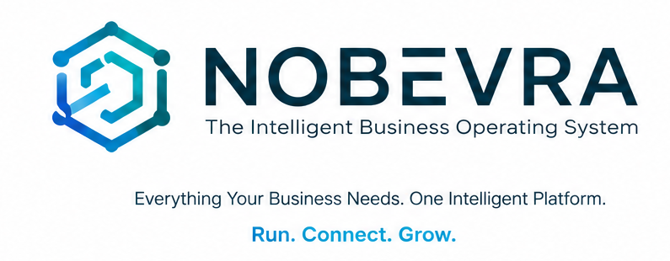
OFFICIAL BRAND IDENTITY GUIDELINES
Version 2.0 | 19 August 2026 | Parent: The Noble's Technology Services
The global-ready identity system for an intelligent business operating system.

BRAND PROMISE
Everything Your Business Needs. One Intelligent Platform.
PRODUCT MANTRA
Run. Connect. Grow.

01. Document Control & Brand Governance
  - The source-of-truth rules for how Nobevra is represented.
Element | Guideline
Brand | Nobevra
Positioning | The Intelligent Business Operating System
Parent / legal entity | The Noble's Technology Services
Brand role | Master product / platform brand
Version | 2.0
Status | Official brand identity and governance guide; legal trademark clearance is separate.
Primary typeface | Inter
Primary digital domain strategy | Use the controlled production hostname until the preferred global domain is legally and operationally ready.
IMPORTANT LEGAL BOUNDARY
This guide establishes brand standards; it does not certify trademark clearance, domain availability, or worldwide legal protection. Trademark, corporate-name, domain and class-specific clearance must be handled by qualified professionals.
Governance principle. Nobevra is the customer-facing product brand. The Noble's Technology Services remains the legal parent entity and should appear where legal ownership, contracts, statutory notices, privacy, terms and compliance require it.

02. Brand Foundation
  - A broader platform identity that can scale beyond invoicing.

What Nobevra is
Nobevra is an all-in-one business toolkit and invoicing platform for businesses and freelancers. It unifies invoicing, CRM, expenses, productivity, QR utilities, business identity, AI, payments, financial intelligence and team collaboration across Web, Mobile and a unified backend.

Brand definition
Element | Guideline
Master definition | Nobevra — The Intelligent Business Operating System.
Brand promise | Everything Your Business Needs. One Intelligent Platform.
Product mantra | Run. Connect. Grow.
Core outcome | Less operational friction, stronger business visibility, faster revenue collection and a more professional digital identity.
Category | Intelligent business operating system / all-in-one business toolkit.

Brand story
Nobevra represents the evolution of business operations from fragmented tools into one connected, intelligent ecosystem. The name is a coined, expandable technology mark designed to preserve a connection to the Noble parent brand while moving the product beyond the narrow invoice category. The brand story may be expressed as Noble + evolution + business intelligence; this is a positioning narrative, not a claimed dictionary etymology.

The three-part value model
Element | Guideline
RUN | Operate the everyday business: invoices, expenses, products, inventory, payments, productivity and workflows.
CONNECT | Build relationships and collaboration: CRM, client communication, portals, teams, business identity, QR and NFC.
GROW | Improve outcomes: analytics, financial intelligence, AI assistance, SEO capabilities, engagement and scalable plans.

03. Audience & Market Role

Primary audiences
- Freelancers and independent professionals who need invoicing, customer management and professional identity tools.
- Small and growing businesses moving beyond spreadsheets and disconnected applications.
- Agencies, consultants and service businesses managing clients, expenses, invoices and teams.
- Businesses operating across currencies or countries and needing payments, reporting and operational visibility.
- Future enterprise customers requiring teams, roles, organization identity, integrations and controlled access.

Strategic category narrative
Do not position Nobevra as only an invoicing application. Invoicing is a core entry point; the strategic category is the broader intelligent business operating system. Product pages should lead with the business outcome and then explain the relevant capabilities.
MESSAGE HIERARCHY
Outcome first → platform value second → capability proof third → technical detail last.

04. Product & Brand Architecture
  - One master brand, descriptive capability names, no unnecessary sub-brand sprawl.
Element | Guideline
Master brand | Nobevra — platform, website, mobile applications and ecosystem.
Core capability | Nobevra Invoicing
Customer relationships | Nobevra CRM
Money & payments | Nobevra Wallet / Payments
Intelligence | Nobevra AI
Teams | Nobevra Teams / Nobevra Enterprise
Identity & networking | Nobevra Business Identity / QR / NFC capabilities
Developer ecosystem | Nobevra API / Nobevra SDK
Naming rule: extensions explain a capability; they do not compete with Nobevra. New customer-facing feature names should pass brand governance before becoming standalone marks.

Capability map
Capability | Brand role / customer value
Invoicing | Professional templates, multiple invoice types, tax, discounts, recurring billing and payment collection.
CRM | Clients, notes, communication logs, client ledger and dynamic client portals.
Expenses | Expense categories, receipt attachments/scanning and vendor management.
Products & Services | Catalogues, categories, stock ledger and Product Passports.
Wallet & Payments | Payment methods, wallet operations, secure gateway integration and multi-currency support.
Growth & Intelligence | Business analytics, billing history and SEO tools for public business presence.
QR Engine | 21 business QR-code types, invoice/payment retrieval and scan analytics.
Business Identity | Business profile, public business cards and synchronized brand identity.
Smart Connect | Client communications, live chat and NFC profile writing.
Teams | Workspace collaboration, roles and team members.
AI | Generative invoice text, receipt-image analysis and conversational commands with usage monitoring.
Notifications | Cross-platform alerts for invoice views, payments and administrative events.
Subscriptions | Free, Pulse and Elite tiers plus granular Pay-As-You-Go entitlements.
Platform resilience | Offline-first caching/sync, gamification and automated image processing.

05. Official Visual Identity System
  - The supplied artwork is the approved v2.0 reference for the identity applications shown below.
The following identity applications are included exactly as represented in the supplied official brand board. Until editable vector masters are formally issued, the supplied artwork should be treated as the visual reference and should not be redrawn or geometrically altered.
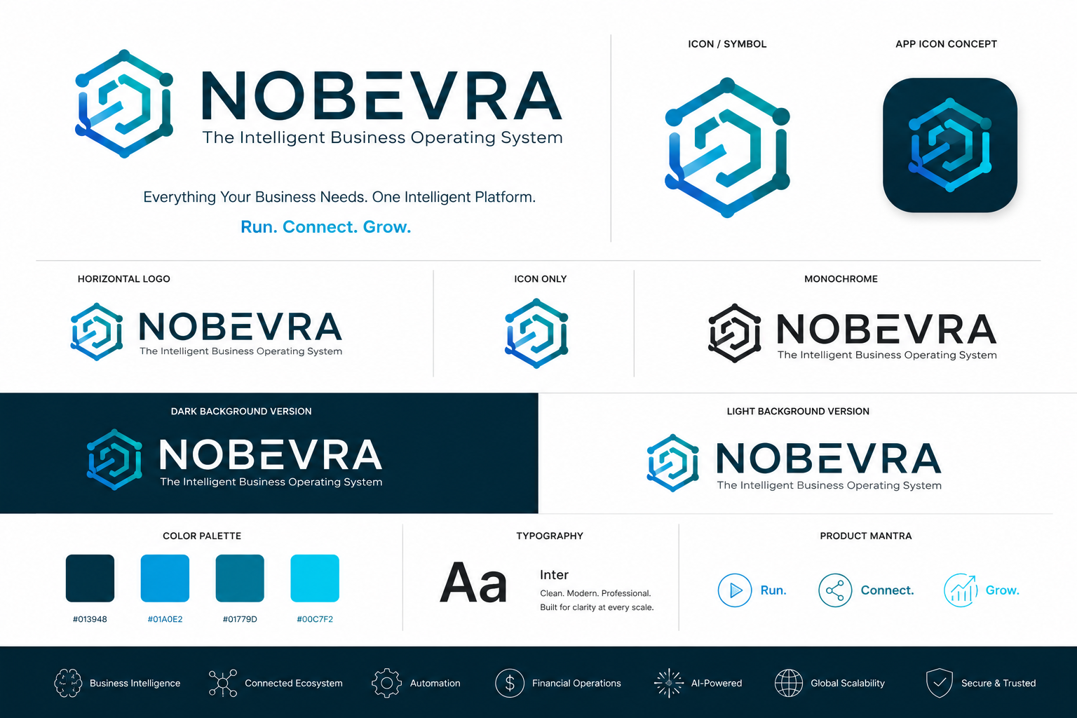
Official identity board supplied for Nobevra.

Primary Logo Lockup
Use for high-visibility brand introductions, corporate presentations and major marketing surfaces.


Icon / Symbol
Use where the brand name is not required or space is constrained.
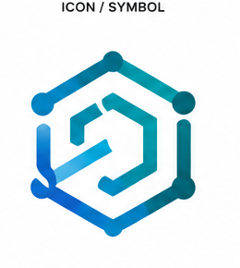

App Icon Concept
Use as the reference for application icon construction and store/device contexts.
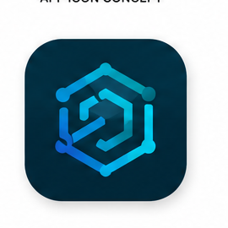

Horizontal Logo
Preferred compact lockup for website headers, dashboards, documents and partner placements.
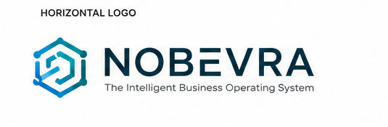

Icon Only
Use for favicons, avatars, compact navigation, app shortcuts and small digital surfaces.


Monochrome
Use when color reproduction is unavailable, restricted or visually inappropriate.
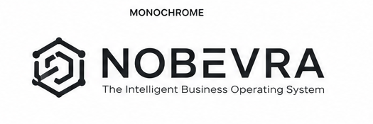

Dark Background Version
Use on approved dark surfaces where the light wordmark maintains strong contrast.


Light Background Version
Preferred light-surface treatment for most documents and digital interfaces.


06. Logo Usage Rules
Element | Guideline
Clear space | Maintain clear space on all sides. The minimum reference unit is the height of the internal document/mark element; never crowd the logo with text, UI controls or other marks.
Minimum size | Do not reduce the full lockup until the wordmark and descriptor remain clearly legible. For very small contexts, switch to the icon-only mark.
Color | Use only the approved full-color, light-background, dark-background or monochrome applications shown in the official artwork.
Background | Prefer clean, quiet surfaces. Do not place the logo over busy imagery or low-contrast textures.
Geometry | Never stretch, skew, rotate, distort, redraw or alter the proportions of the symbol or wordmark.
Effects | Do not add arbitrary shadows, glows, outlines, bevels or gradients outside the supplied artwork.
Co-branding | Give partner logos their own protected space; do not visually merge them with the Nobevra symbol.

Never do
- Do not recreate the logo with a different typeface.
- Do not recolor the mark with unapproved hues.
- Do not compress or stretch the wordmark.
- Do not place the full logo on visually noisy imagery.
- Do not add decorative frames, badges or containers that imply a new logo variant.
- Do not use an old NobleInvoice logo as a primary brand mark after migration.

07. Color System
  - A restrained teal-to-blue system built for trust, intelligence and action.
Color | HEX | Primary use
Nobevra Navy | #013948 | Primary dark surface, logo depth, navigation, primary text on light surfaces.
Nobevra Blue | #01A0E2 | Primary actions, links, active states and key highlights.
Nobevra Teal | #01779D | Secondary actions, charts, supporting UI and information emphasis.
Nobevra Cyan | #00C7F2 | Sparingly for AI/innovation moments, accents and visual energy.
White | #FFFFFF | Light surfaces and negative space.
Cloud | #F4F9FC | App backgrounds, cards and page surfaces.
Ink | #0B1720 | Maximum-readability body text.
Production note: the supplied v1.0 guide states that the HEX values were derived from the supplied logo artwork. Before mass production, normalize the palette against the original vector master and verify digital/print color profiles.

Semantic UI colors
Element | Guideline
Positive / success | Green family reserved for successful business or financial states.
Attention / pending | Amber family reserved for warnings, pending actions and attention states.
Destructive / error | Red family reserved for errors, failed actions and destructive confirmation states.
Brand blue | Not a replacement for semantic status colors; use blue primarily for action, navigation and intelligence.

08. Typography
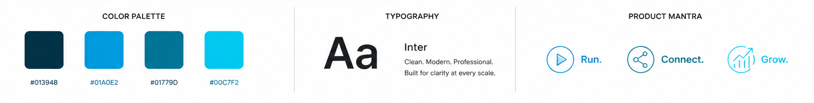
Element | Guideline
Typeface | Inter
Display / hero | Inter Bold / ExtraBold; strong hierarchy, short lines and confident scale.
Subheadings | Inter Semibold.
Body | Inter Regular / Medium.
Numbers / financial figures | Inter Semibold / Bold with tabular numerals where supported.
Fallback | Use a platform-safe sans-serif fallback only when Inter cannot be delivered; do not introduce a decorative display face.

Recommended hierarchy
Element | Guideline
H1 | Large, decisive, outcome-led. Avoid long feature lists in hero headlines.
H2 | Clear section promise or capability.
Body | Short paragraphs, generous line height, readable measure.
UI labels | Concise, action-oriented, consistent capitalization.
Data | Tabular numerals where comparison and financial scanning matter.

09. Layout, UI & Digital Experience
- Use white/cloud surfaces with deep-teal text and electric-blue actions as the default product language.
- Use blue as a signal of action and intelligence—not as decoration everywhere.
- Build clear hierarchy with generous spacing, strong alignment and short labels.
- Keep interaction states consistent across Web and Mobile: default, hover/focus, pressed, disabled, loading, success, warning and error.
- Use one coherent icon family across platforms wherever practical.
- Design accessibility into the brand: readable contrast, visible focus, scalable text and appropriate mobile touch targets.
- Prefer authentic product screenshots and current UI; never show fake metrics, unavailable capabilities or misleading interface states.

Digital brand tokens
Element | Guideline
Primary action | Nobevra Blue #01A0E2.
Primary dark | Nobevra Navy #013948.
Surface | White #FFFFFF / Cloud #F4F9FC.
Text | Ink #0B1720 for maximum readability.
Accent | Nobevra Cyan #00C7F2 used sparingly.
Corner language | Use restrained, consistent radii; avoid excessive pill-shaped UI unless functionally justified.
Density | Information-rich but calm. Financial/productivity interfaces should feel efficient, not crowded.

10. Imagery, Illustration & Motion
Element | Guideline
People | Show real business contexts across regions, genders, ages and business types without stereotypes.
Workspaces | Clean, modern and believable; restrained teal/blue accents should echo the product.
Product screenshots | Authentic, current and traceable to actual product capabilities.
Illustration | Simple, geometric and functional; avoid competing with the logo's connected-structure language.
Photography | Natural light, credible business moments, human confidence rather than staged corporate perfection.
Motion | Fast, precise and purposeful. Favor subtle transitions, connected flows and progress metaphors.
Campaign thumbnails | One dominant idea, 3–6 words of high-impact text, strong contrast and an unmistakable Nobevra cue.
Do not make one recurring human model the permanent face of Nobevra. Campaign people are campaign assets; the product identity remains the brand.

11. Verbal Identity & Voice
Element | Guideline
Intelligent | Clear, confident and practical; avoid jargon-heavy language.
Professional | Precise and trustworthy; avoid corporate stiffness.
Empowering | Action-oriented and encouraging; avoid pressure tactics.
Modern | Simple, crisp and digital-first; avoid trend-chasing slang.
Global | Inclusive and culturally neutral; avoid region-specific assumptions.
Human | Helpful and warm; avoid overly robotic AI language.

Writing principles
- Lead with the user's outcome, not the feature.
- Prefer plain language over technical vocabulary in customer-facing copy.
- Use active verbs: create, send, collect, track, connect, analyze, grow.
- Make intelligence feel useful and controlled—not mysterious or magical.
- Never imply guaranteed revenue, guaranteed savings or guaranteed business growth.
- Keep the brand confident without making exaggerated claims.
PREFERRED MESSAGE PATTERN
Get paid faster and keep your business organized. Nobevra brings invoicing, clients, expenses, payments and business intelligence together in one platform.

12. Messaging Architecture
Element | Guideline
Brand level | Nobevra — The Intelligent Business Operating System.
Promise | Everything Your Business Needs. One Intelligent Platform.
Functional proof | Invoicing + CRM + expenses + productivity + payments + identity + QR + AI + teams + financial intelligence.
Emotional benefit | Feel in control, look professional and spend less time switching between disconnected tools.
Business outcome | Operate with clarity, connect with customers and teams, and make better decisions.

Approved short descriptors
- Intelligent business operating system
- All-in-one business toolkit
- Invoicing, CRM, expenses and business intelligence in one platform
- Business operations, connected

Claims discipline
Every product claim should be traceable to an implemented capability or a clearly labeled roadmap item. Avoid fabricated customer counts, revenue figures, performance promises, security certifications or feature claims that cannot be substantiated.

13. Product Experience Brand Map

Run
- Invoicing: standard, proforma, recurring, estimate, quote, progress, commercial, final, credit memo, debit memo and mixed invoice workflows.
- Expenses: categories, receipt attachments/scanning and vendor management.
- Products & services: catalogues, categories, inventory ledger and Product Passports.
- Wallet & payments: payment methods, wallet operations, gateway checkout and currency services.
- Productivity: dashboard visibility, notifications, offline-first workflows and engagement mechanics.

Connect
- CRM: clients, notes, communication logs, ledgers and client portals.
- Business identity: public business cards and synchronized profile branding.
- Smart Connect: live client communications and support interactions.
- QR: 21 QR code types plus scan logging and engagement analytics.
- NFC: business-profile writing to compatible NFC tags.
- Teams: role-based collaboration within shared workspaces.

Grow
- Growth reports: business health, analytics and billing history.
- SEO subsystem: articles, rankings tracking and keyword management for public business presence.
- AI: invoice text generation, receipt-image analysis and conversational commands.
- Financial intelligence: multi-currency visibility and operational insight.
- Subscriptions: Free, Pulse and Elite plans with granular Pay-As-You-Go entitlements.

14. Trust, Security & Reliability Language
Nobevra's brand should communicate confidence without making unsupported security or compliance claims. Product communications may describe implemented controls and architecture accurately, but certification claims require evidence.
Element | Guideline
Authentication | Supabase Auth and Firebase Auth integrations; email and third-party provider sign-in as implemented.
Device access | BiometricService support where enabled by the product and device.
Workspace isolation | User/workspace provisioning and role-based team collaboration as implemented.
Notifications | Cross-platform notification routing via FCM infrastructure.
Offline-first | Core cached workflows can operate offline and synchronize when connectivity returns, subject to actual implementation.
AI governance | AI usage monitoring/token controls should be described factually; do not imply human-equivalent reasoning or guaranteed outcomes.
TRUST RULE
Say what the product does. Do not say what it has not been independently verified or certified to do.

15. Cross-Platform Brand Standards
Element | Guideline
Web | Use Nobevra as the master product name; maintain consistent favicon, metadata, OpenGraph, structured data and visual tokens.
Mobile | Use Nobevra as the display brand; the supplied app icon concept is the visual reference.
Documents / PDFs | Use approved light/dark logo applications, Inter and the core palette.
Invoice templates | Customer customization may change the customer's brand, but Nobevra platform attribution should remain governed.
QR codes | Public QR payloads and destinations should use the current canonical brand/domain strategy.
Email | Sender identity, templates, footer and links should consistently use Nobevra and the correct legal entity where required.
Social | Use consistent official handles where available; avoid unrelated variations.
App stores | Product name, screenshots, iconography, descriptions and package/bundle identifiers should be finalized before publication.

16. Naming, Domain & Digital Identity Strategy
- Use Nobevra consistently in page titles, H1s, metadata, OpenGraph, schema, app listings and social profiles.
- Pair the coined brand with descriptive category language: “Nobevra — Business Operating System”, “Nobevra invoicing software”, “Nobevra CRM”.
- Do not keyword-stuff. Build topical authority around invoicing, business management, CRM, expenses, payments, AI productivity and business identity.
- Use one canonical public domain once the preferred domain is acquired, legally reviewed, technically configured and stable.
- Retire legacy NobleInvoice-facing marketing as the rebrand becomes established.
MIGRATION PRINCIPLE
Change public-facing identifiers first; change internal identifiers when safe and economically useful. Do not create production risk merely to make internal names look new.

17. Brand Governance & Asset Management
Element | Guideline
Brand owner | The Noble's Technology Services / authorized Nobevra brand owner.
Design authority | The designated brand/design lead or approved agency partner.
Product authority | Product leadership controls feature naming and customer-facing capability taxonomy.
Engineering authority | Engineering controls implementation tokens, package identifiers and technical naming within brand rules.
Marketing authority | Marketing controls campaign expression, messaging and channel execution within approved identity.
Legal authority | Qualified counsel controls trademark, domain, corporate-name and regulatory determinations.

Non-negotiables
- Nobevra is the product brand; The Noble's Technology Services is the legal parent entity.
- Never use NobleInvoice as the primary long-term product brand after migration.
- Never claim legal/trademark clearance without professional evidence.
- Never introduce a new logo color, font or product sub-brand casually.
- Never publish misleading screenshots, fabricated customer counts, fabricated revenue or unavailable features.
- Never sacrifice accessibility for visual style.
- Every major brand change must propagate across web, mobile, legal, SEO, social, email and product surfaces.

18. Brand Migration & Launch Checklist
- ☐ Nobevra name approved internally
- ☐ Trademark clearance plan scheduled with qualified counsel
- ☐ Primary domain strategy confirmed and documented
- ☐ Official logo master files exported in SVG/PNG and monochrome variants
- ☐ Inter font system applied consistently
- ☐ Color tokens centralized
- ☐ Web metadata and product naming updated
- ☐ Flutter app display name and icons updated
- ☐ Android package identifier finalized before Play publication
- ☐ iOS bundle identifier finalized before App Store publication
- ☐ GitHub repository / documentation reviewed for public legacy naming
- ☐ Supabase auth redirect URLs reviewed
- ☐ Email templates and sender identity updated
- ☐ Invoice/PDF branding updated
- ☐ QR codes and public URLs reviewed
- ☐ Privacy / Terms / Compliance pages updated
- ☐ Analytics / Search Console / OpenGraph reviewed
- ☐ YouTube and social brand assets updated
- ☐ Canonical redirects and SEO migration tested
- ☐ Cross-platform QA completed

19. One-Page Brand Quick Reference

Element | Guideline
Name | NOBEVRA
Position | The Intelligent Business Operating System
Promise | Everything Your Business Needs. One Intelligent Platform.
Mantra | Run. Connect. Grow.
Primary font | Inter
Core colors | #013948 | #01A0E2 | #01779D | #00C7F2
Personality | Intelligent • Professional • Empowering • Modern • Global • Human
Master-brand rule | One brand; descriptive capabilities; no unnecessary sub-brands.
Logo rule | Use approved artwork only; preserve proportions, clear space and contrast.
Claim rule | Outcome-led, evidence-based, globally inclusive, never misleading.

FINAL BRAND DEFINITION
NOBEVRA — The Intelligent Business Operating System. Everything Your Business Needs. One Intelligent Platform. RUN. CONNECT. GROW.

20. Appendix: Official Identity Asset Register
Element | Guideline
Primary lockup | Official supplied artwork — full symbol + wordmark + descriptor.
Symbol | Official supplied artwork — standalone mark.
App icon concept | Official supplied artwork — dark rounded-square application treatment.
Horizontal logo | Official supplied artwork — compact horizontal lockup.
Icon only | Official supplied artwork — compact standalone mark.
Monochrome | Official supplied artwork — single-color application.
Dark background version | Official supplied artwork — light wordmark on dark surface.
Light background version | Official supplied artwork — primary light-surface application.
Color palette | Official supplied reference values; normalize against vector masters before mass rollout.
Typography | Inter family; approved hierarchy defined in this guide.
Product mantra | Run. Connect. Grow.
Asset-control note: maintain a master asset repository containing editable vector originals (SVG/AI/EPS where applicable), transparent PNG exports, app-icon exports, monochrome versions, social/avatar variants and documented checksums/version history. This document contains reference crops from the supplied brand board; it is not a substitute for editable vector masters.

NOBEVRA
The Intelligent Business Operating System
Run. Connect. Grow.
Official Brand Identity Guidelines • Version 2.0 • 19 August 2026

